CS5551 Advanced Software Engineering Lab Assignment #3

***Embedding Social login using OAuth2.0, Facebook and Google logins and mashup of two web services using their API’s.***

***Technology used:*** HTML5/CSS, JavaScript, Bootstrap, Chrome browser

**Screenshots:**

1. **Login Page**

# C:\Users\ACHU\AppData\Local\Microsoft\Windows\INetCacheContent.Word\1.png

1. **Login via Email:**

If the email and password are valid, you will be logged in succsfully, we get a window alert for it.

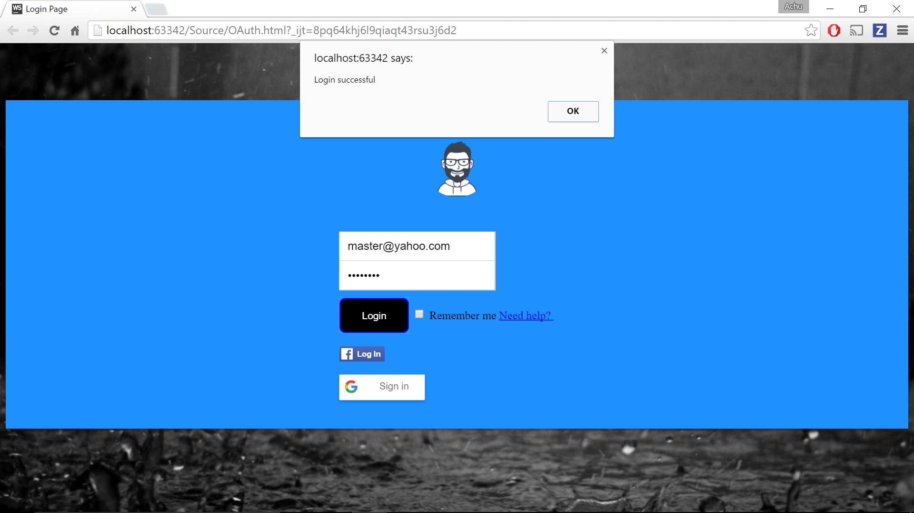

1. **Login via Facebook**

Here we input our Facebook user id and password then it uses OAuth 2.0 and then successfully log in and will redirect to our mashup app page.

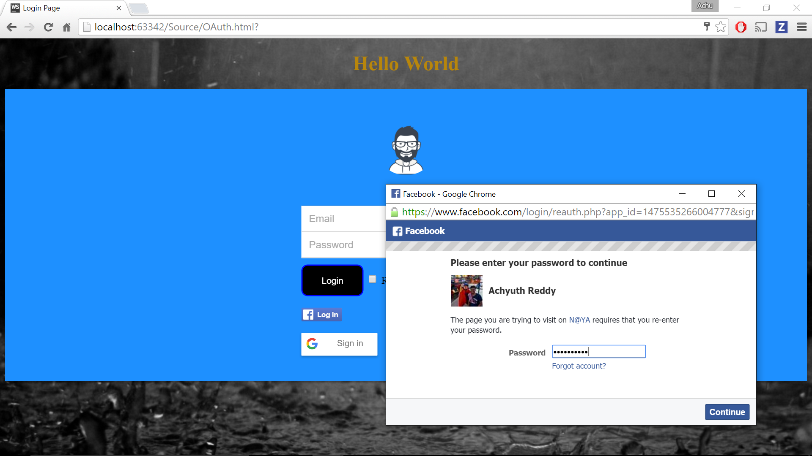

Once the credentials are authenticated, it redirects to html page

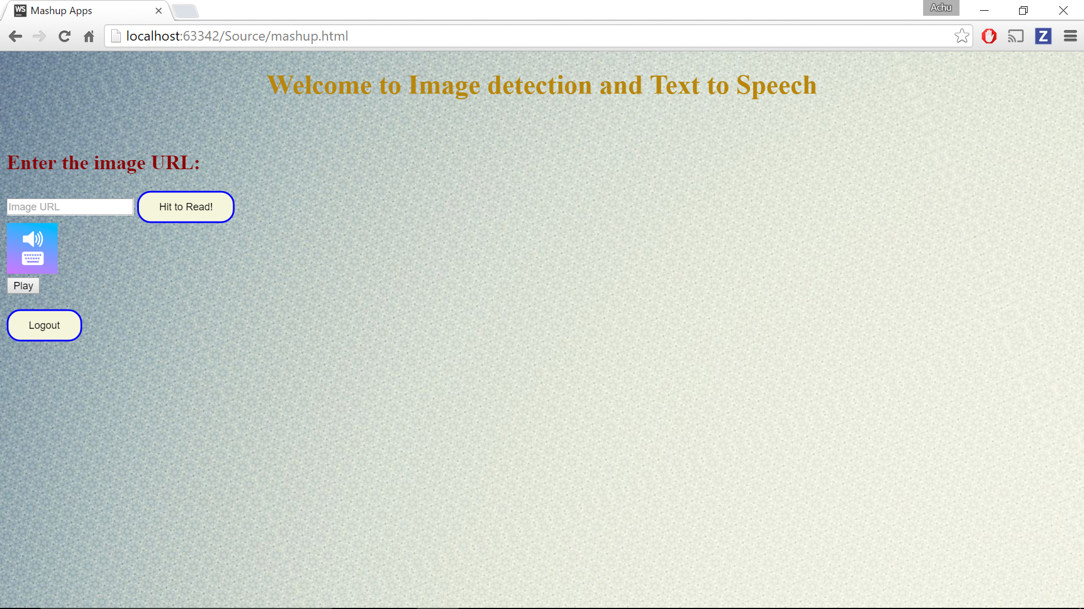

1. **Email Login validation**

If the email and password are not provided correctly, it alerts us to provide correct credentials and shows remaining login attempts.

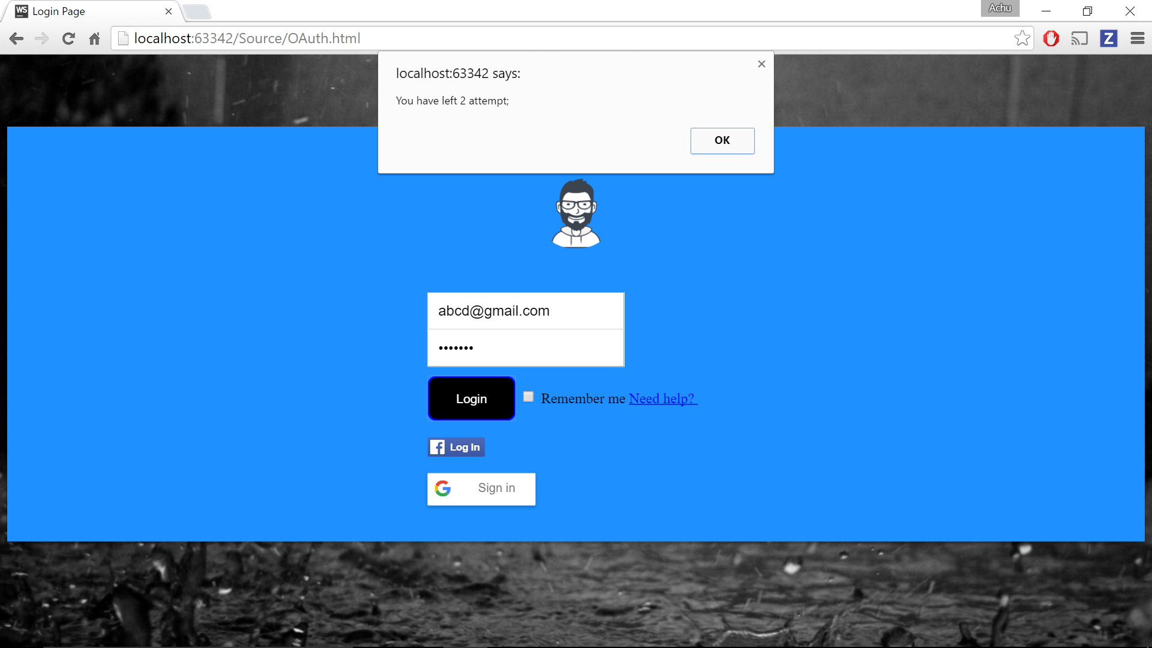

If we provide only password and email field empty it shows alert to fill the Email field

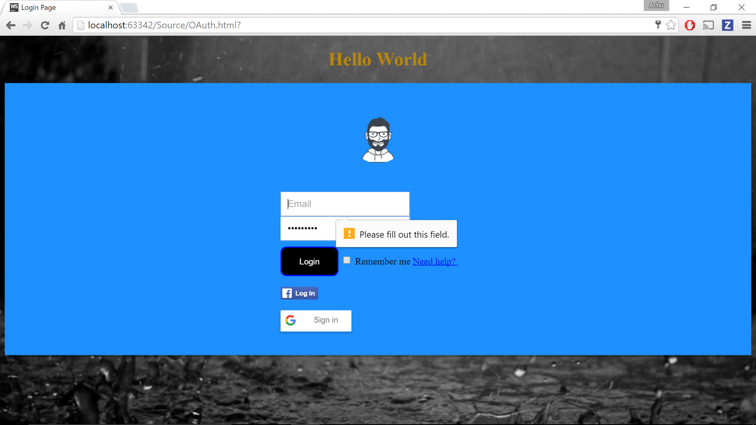

1. **Mashup App page**

* Mash up of Clarify API and Responsivevoice.org, the Clarify API takes image address as input and analyses the image and gives the description of image and its contents.
* Responsive voice API reads out the text input which is given by Clarify API.
* The below screenshot shows basketball players in a stadium.

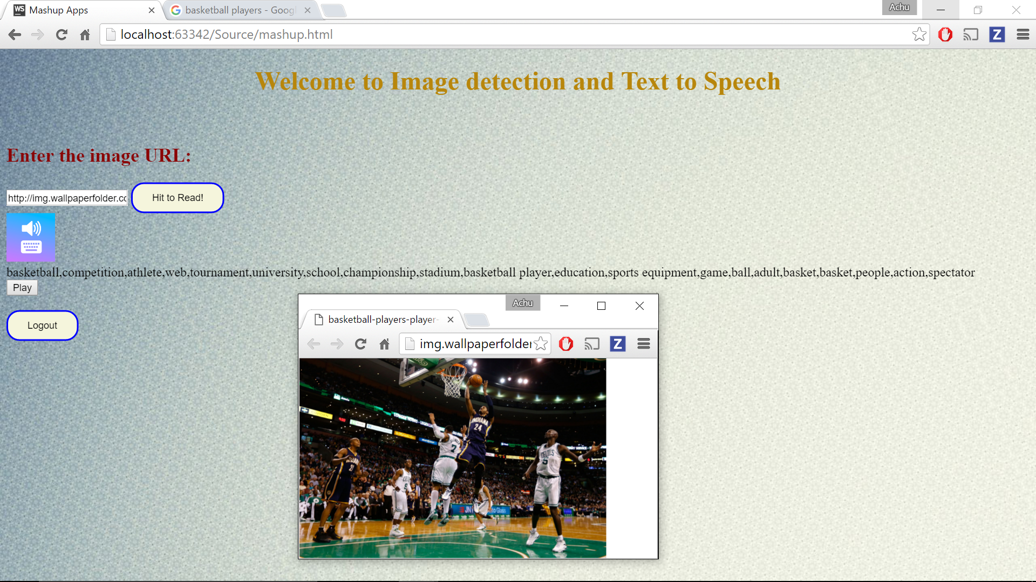

**References:**

* <https://developers.facebook.com/>
* [https://responsivevoice.org/](http://responsivevoice.org/)
* <https://clarifai.com/>
* <https://developers.google.com/>
* Class Tutorial